
Our prayers have been requested by or for the following members of our church family and those beyond our doors.

Long Term Prayer List
Patty, Laura, Jerry, Susan, Mel, Jarod, Lance, Alice, Shayne, George, Ruth, Rachel, Larry, the Bentley Family, Shirley, Pam,Vi, Diane, Julie, Prof. Dr. Ahmed Adel Sakr

Short Term Prayer List
Esther Guimord, Cristina Diduch,
Franklin Camp, Charlie, Max Masters, Benjamin Jackson,
Avery, Greg, Shana, David, Paul S., A. J. Garibaldi,
Dorothy Outerbridge, Bobby Hitchcock, Jillian Hajdasz,
Andrew Massara, Terry Mahan,
Elijah McCarthy, Jamie McCarthy, Brian & Diane P.,
Bob Cornwell, The Family of Ina Greer,
Don Van Meter, Bridgette Van Meter,
Rodney Jensen, Ruth Ogden, Bishop Onell Soto, Chad, David,
MartinaTeh, The Buchanan Family, Tae Edell, Pat Byrne,
Robert Marsh, Bill Odio, Janeane Edell, Jenny Neaveill
Victor R. Padilla, Pam,
George Chadwick, III, Bill, Rick,
Ron & Candy Bornmann, Ben & Courtney Williams, Matthew, Louisa;
Doug, Bernadette and Andrea Harper, Beth Hwoschinsky, George Beach

Altar Flowers
The flowers on the altar this morning are given to the Glory of God by Peter and Beth Hwoschinsky in loving memory of Donna Hurley, their sister-in-law. If you would like to give the altar flowers one week in memory of or in thanksgiving for someone, please fill out a flower envelope or call the office at 703-437-3790.

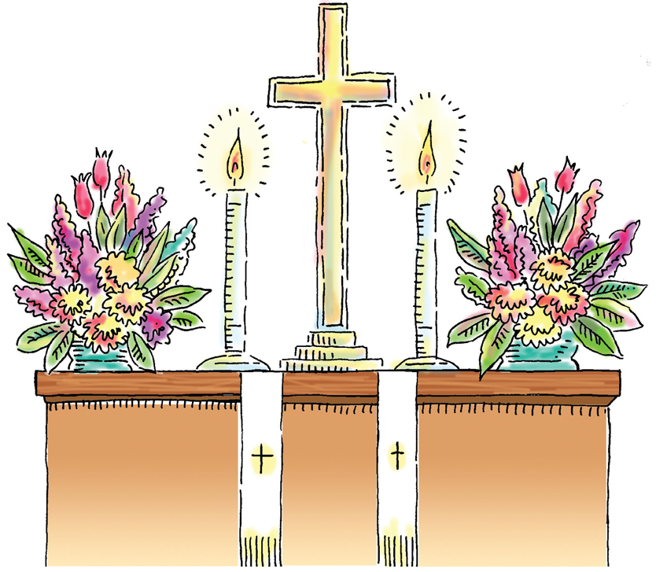
Next Week’s Lessons: September 18 – Pentecost 14
Jonah 3:10-4:11
Psalm 145:1-8
Philippians 1:21-30
Matthew 20:1-16
Preaching: The Rev. Leslie H. Chadwick, Associate Rector


Sunday School Registration is now open!

Please check for forms on the Christian Education Table Or On the web!!!! We need a registration form for every child participating in Sunday morning classes this school year. The teachers will give each student a form today. You can also find forms on the Christian Ed table in Henry Hall or on our website. Please put the completed forms in Cassandra’s mailbox.

Staff

The Rev. Bradford A. Rundlett, Rector
The Rev. Leslie Chadwick, Associate Rector
Mr. Peter Waggoner, Director of Music
Ms. Cassandra Riedy, Director of Christian Education
Ms. Keith Nelsen Stroud, Director of Parish Operations

Vestry
Senior Warden – Kathy Lombard
Junior Warden – Ted Mankin
Treasurer - Rick Wilson
Registrar – Rose Berberich

Liz Ward Cheryl Brock Mike Colie Patrick Hobson Allison Dodd Duncan Hutcheon Donna Cornwell
Eugene Nkomba Sandy Wright Beth Lumnitzer Jeanne Bennett, Alternate

Trustees
Tom McLenigan Keith Sinclair Dana “Deke” Smith

Resident Clergy
The Rev. Maeva Harris-Bayfield
The Rev. Dr. Ralph W. Bayfield

Pastoral Psychotherapist
Ann Crawford Newland

Assisting in the Preparation and Conduct of Worship
Altar Guild
Mary McLenigan, Sandy Wright, Stephanie Wolo
Counters
Keith & Tina Pinkard
Ushers
8:00 am Bill Sanger & Glenn Pfadenhauer
9:30 am Randy & Patti Karn
11:00 am Chris & Susan Smith
Greeters
8:00 am Bill & Dorothy Outerbridge
9:30 am Sandy Wright
11:00 am Thelma Hubert
Lay Eucharistic Ministers
8:00 am Eugene Nkomba & Ralph Tildon
9:30 am Susan Simmons, Gayle Rippe, Rod Neaveill, Cheryl Brock
11:00 am Michael Cook, Betsy Knoizen, Bill Odio, Dave Parker, Keith Sinclair
Acolytes
9:30 am Christopher Wilson, Beau LaWalt, Will LaWalt & Max Weeden
11:00 am Christopher Showalter, Jack Norcross, Evelyn Showalter, Max Norcross

Need a listener for the long term?
Ask a Stephen Minister
or Call Fr. Brad at 703-437-3790.

Announcements
For
September 11, 2011
The Thirteenth Sunday after Pentecost

Welcome Home Sunday

8:00 am Holy Eucharist – Rite I
9:30 am Holy Eucharist – Rite II
11:00 am Holy Baptism– Rite II

Genevieve Victoria Masters
Maximilian Justus Masters

St. Timothy’s Episcopal Church
432 Van Buren Street, Herndon, Virginia 20170



Parish Office: 703-437-3790 Fax: 703-787-9781
Web Page: www.saint-timothys.org
Office E-mail: office@saint-timothys.org

St. Timothy’s Mission Statement

As people of God, we joyfully worship God,
spread the WORD of God’s love
Treasure all people, and
serve others everywhere in the Name of Jesus Christ.

Therefore, with God’s help, we:
Open our doors to everyone,
Open our hearts in worship,
Open our eyes to the Spirit’s gifts, and
Open our arms to embrace God’s work.

SUNDAY – 9/11
Welcome Home Sunday
Holy Eucharist 8, 9:30, 11:00
Commissioning of Sunday School Teachers – 9:30 AM & 11:00 AM
Sunday School Begins following the Commissioning
Holy Eucharist 8, 9:30, 11:00

MONDAY – 9/12
12:15 PM Monday Gratitude -Upper Rm
7:00 PM BSA Troop 159 Meeting - HH/UR
7:00 PM Herndon Group AA - Rm A5
7:00 PM Hope Al-Anon Mtg. - Rm A3
7:00 PM Service Ministry Meeting - B1
7:00 PM Stephen Ministry Peer Supervision - B1
8:30 PM Herndon Group AA - Rm A5
8:30 PM Just for Today - Al-Anon Rm A3

TUESDAY – 9/6
9:00 AM EfM - B1
10:00 AM How It Works Upper Rm
6:00 PM St. Cecilia Choir Rehearsal
6:30 PM Taking Off Pounds Sensibly #364 - RmB1
7:00 PM Big Book RmA3
7:00 PM Stephen Ministry Peer Group- Upper Room
7:30 PM Handbell Choir Rehearsal
8:00 PM 12&12 Al-Anon Rm A8

WEDNESDAY – 9/7
9:00 AM Pre-School - B1
10:00 AM Morning Bible Study - Kitchen
12:00 PM Pre-School - B1
12:15 PM Holy Eucharist/Healing Service
7:00 PM OA Men's Meeting - UR
7:00 PM St. Timothy's Shawl Ministry - Narthex
7:30 PM SA RmA1
8:30 PM New Hopefuls - NA –HH

THURSDAY – 9/8
9:00 AM Pre-School - B1
10:00 AM Wee Got the Beat - Nursery
12:15 PM Came to Believe - AA - Upper Rm
6:30 PM Hunter's Woods Group - A1 & A5
7:00 PM Freedom from Debt - UR
7:00 PM La Leche League - Nursery
7:00 PM Taoist Tai Chi - Internal Arts for Health - HH
7:15 PM St. Ambrose Choir Rehearsal

FRIDAY- 9/9
10:00 AM Friday Gratitude - Upper Room
10:30 AM Friday Folders - Kitchen
6:30 PM Phoenix Reflections - Women's AA - A3

SATURDAY – 9/10
9:00 AM Altar Guild Set-Up - Sanctuary and Altar Guild Room
11:00 AM Dorosheff Violin Lessons - Music Room/Sanctuary
4:00 PM Baker Wedding - Sanctuary
8:00 AM Finance Ministry - Monthly Meeting - UR
9:00 AM Altar Guild Set-Up and Training- Sanctuary and Altar Guild Room
10:00 AM Kumon Math Tutor Rm A3
11:00 AM Baptismal Rehearsal - Sanctuary
11:00 AM Dorosheff Violin Lessons - Music Room/Sanctuary
2:00 PM 11th Step Conscious Contact Group - B2
6:00 PM Youth Group Candy Tournament - HH & Narthex
6:30 PM Recovering Couples Anonymous - B2
8:30 PM Herndon Group AA - Rm A5
Editor’s Note
All of our 12-step groups and the others that St. Timothy’s hosts have been included in Events this Week so that members of the congregation can see the scope of work that is done here throughout the week. This is Stewardship to the community and to ourselves. Giving back in grateful thanksgiving for all that we have been given by God.

What? know ye not that your body is the temple of the Holy Ghost which is in you, which ye have of God, and ye are not your own? For ye are bought with a price: therefore glorify God in your body, and in your spirit, which are God's.
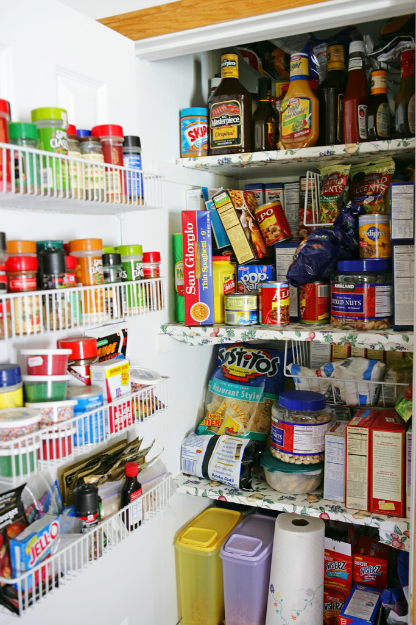
I Cor. 6:19-20

Special Alert!!! Please assist us in replenishing the food cupboard. We are very low once again. Your generosity helps so many hungry families and homeless individuals. For a list of foods needed, call the office at 703-437-3790. Thank you for enabling us to serve the wider Body of Christ in this way.

Nursery

All children are welcome to stay with parents in the Sanctuary during worship. However, for parents of children ages 0-2.5 years who want nursery care, we have a well-equipped and professionally-staffed nursery at the end of the hall nearest the Sanctuary. Each child brought to the nursery is given a number; only the parents of the child can take the child from the nursery. If a parent is needed during worship, the child’s number will appear (in red LED’s) on the black panels beneath the hymn boards on both sides of the Chancel. Parents! Please bring diapers and any snacks, formula as needed for your child.

Holy Communion

All baptized Christians are welcome to receive the Sacrament. If you have not been baptized, please come to the Altar rail for a blessing during Holy Communion (place your arms across your chest to signify your desire for a blessing). If you would like to be baptized, please speak with the clergy after the service. To receive Holy Communion, accept the bread in your hand and place it in your mouth, then sip wine from the Chalice when it is brought to you (guide the Chalice to your mouth please), or hold the bread, dip it in the wine when the chalice comes to you, and place the bread with wine in your mouth. If you are allergic to wheat or are gluten intolerant, please let the person serving bread know to give you a rice wafer.
St. Tim’s Cards for a Cause (previously known as Scrip) will return on Sunday, October 2 after each of the services. --Look for the “St. Tim’s Cards for a Cause” Table in Henry Hall. --Purchase Giant Gift Cards at the face value of the card (cash and checks only please). --Redeem them for groceries at any Giant Food Store. St. Timothy’s receives 5% of every dollar purchased. 5% may not seem like a lot, but, for example, if 10 people purchase $100 in Giant Cards from our table, St. Tim’s receives $50. Over time, that will begin to add up, and just by doing what we all do, buying groceries. So, stop by on Sunday, October 2 and buy your gift cards, do your regular shopping and support St. Tim’s and its many ministries throughout our community and the world. If you have any questions, contact Cheryl Brock at 703-437-3968 or charlieandmaggie@hotmail.com.

Happy Birthday to You!!!
Sun. 9/11 James Hendrick, Joni Ogden, Jill Norcross, Isabel Adams
Schrock
Mon. 9/12 Catherine Hutcheon, Anna Menjivar, Christopher Draper
Tues. 9/13 Alan Leeth, John Bartolomeo, Evan Lehner, Ethan Rundlett
Wed. 9/14 Jeremy Wilkinson, Christopher Wilson
Thurs. 9/15 Thelma Hubert, Dianna Traub
Fri. 9/16 Cynthia McLaughlin
Sat. 9/17 Margaret Moss
Sun. 9/18 Michelle Duquette, Margaret Perkinson, Julius Koenig

Walk for Homelessness
Join Reston Interfaith and Take Steps with others to End Homelessness Be part of the 2011 Reston Interfaith Help the Homeless Walk Program and raise public awareness of the issues surrounding homelessness, while providing support to prevent and end homelessness in your community. For more information visit www.restoninterfaith.org and click on News and Events or contact Kitta Crawley at Kitta.crawley@restontinterfaith.org or call 571-323-9570.

Food Table Ministry Needs YOU!!!
As the fall and a new school year are upon us, how about considering volunteering for a weekly shift at St. Tim's Food Table? We are in immediate need of additional volunteers who will greet guests in need of food, diapers, food cards, bus tokens. Our volunteer hosts will occasionally direct other visitors to meetings, etc. 2-hour shifts are recommended, but any amount of time is greatly appreciated. This is a valuable and very successful ministry for our community, and it also provides much needed help to our clergy and staff. If you're interested, please contact Katie Mazza at katiemazza@yahoo.com or 703-421-3979.

Would you like to ZUMBA? The count is rising…Up to 5!!! We will begin the class during the last week in September. So far there are five brave souls who have “salsa-ed” up to do a Zumba class together. Where are the rest of you? I have the tapes and two sets of sticks. I may even have a person who will quasi-lead us. It will be a blast. If you are interested, call the office and leave a message. We will meet probably during the day or during lunch. When you call, leave word as to your generally preferred time. Let’s get those Salsa rhythms going. Men and women of all ages…kids too…are welcome. Call the office and leave word. 703-437-3790, ext. 10. …come on, folks, you know you want to salsa with us!!! Cha-cha-cha!!!

Welcome Home Sunday

School programs start again on “Welcome Home Sunday” this morning. Today is also the tenth anniversary of the 9/11 attacks. We will commission our Sunday School teachers, have our first class of the new season, and remember 9/11 in the sermon and our prayers. Everyone is welcome to come to Henry Hall after each service where there will be special refreshments for adults and children. On this somber day in US history, there will be a chance to exchange remembrances both verbally and in writing. A 10th anniversary commemorative album will be available for written offerings and this will be added to the church records for future generations. Let us wish each other a blessed, peaceful, and successful year at St. Timothy's and thank God for all His blessings upon us as we enjoy these moments of fellowship and goodwill.
Candy Tournament: September 17, 6pm, Henry Hall Come One, Come All....Youth Groupers! Youth of Saint Timothy's – please come for a night of games and sugary prizes! We will provide dinner and follow it with multiple funtitions like bean bag throw, bingo and ring toss. We will also try to provide smiles, fun and feelings of joy! Questions? Please ask Cassandra Riedy at cassandrar@saint-timothys.org or (703)795-9724.
PLEASE help the Candy Tournament!
We are accepting donations for the Candy Tournament in the form of candy or time. They would be greatly appreciated. Questions? Please ask Cassandra Riedy at cassandrar@saint-timothys.org or (703)795-9724.
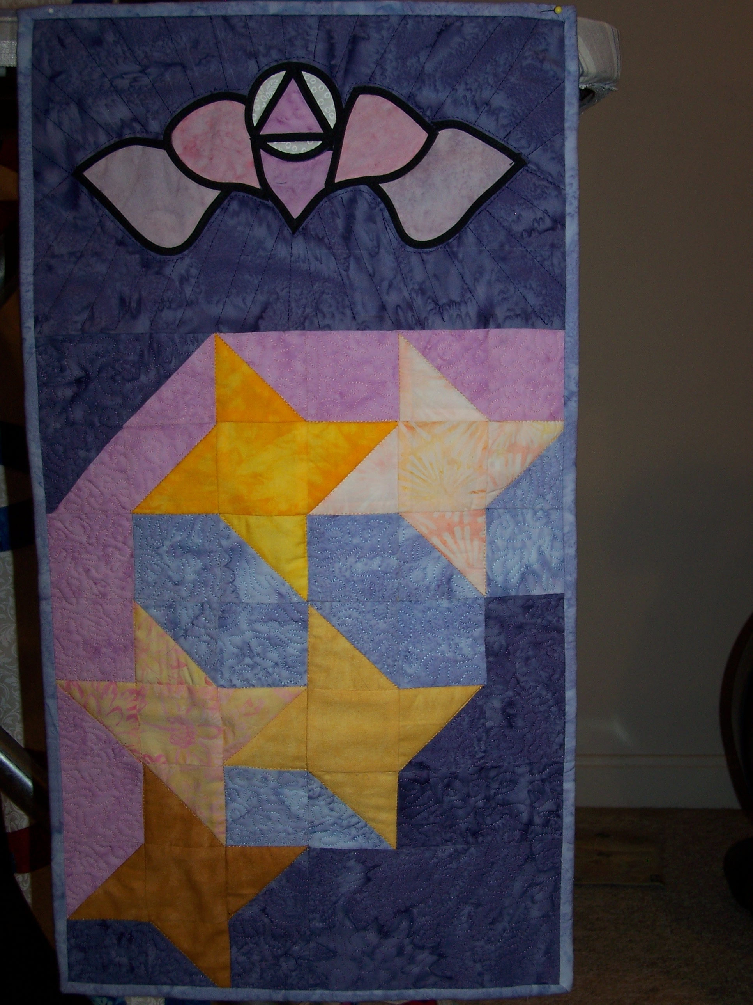
Take a Chance to help Gifts to Glorify the Lord
The organ/reserve campaign has encouraged St. Timothy’s members to be creative in ways to help raise funds. Shirley Ratliff, a noted quilt maker and St. Tim’s parishioner, has donated a beautiful quilt wall hanging for a lottery on Gifts to Glorify Sunday, September 18th. Tickets can be purchased after every service and at the 4pm King Street Brass concert later that afternoon. So bring your wallet and checkbook and take a chance to win this beautiful work of art and help the campaign, too.
E.C.W. Dessert and Coffee Evening - Sunday September 25th at 7:00pm All women in the church are invited to share some delicious desserts with a chance to chat and exchange ideas for activities in the coming year. Child care will be provided and there is no charge! There will be sign-up sheets for some ideas already suggested, based on their success last year, but please come with your own ideas and, more importantly, enjoy the company of your sisters in Christ, both young and old. Everyone is welcome!

