Offertory Hymn Sing ye faithful, sing with gladness Hymnal 492

The Great Thanksgiving

Celebrant: The Lord be with you.
People: And also with you.
Celebrant: Lift up your hearts.
People: We lift them to the Lord.
Celebrant: Let us give thanks to the Lord our God.
People: It is right to give him thanks and praise.

It is right, and a good and joyful thing, always and everywhere to give thanks to you, Father Almighty, Creator of heaven and earth. For by water and the Holy Spirit you have made us a new people in Jesus Christ our Lord, to show forth your glory in all the world. Therefore we praise you, joining our voices with Angels and Archangels and with all the company of heaven, who for ever sing this hymn to proclaim the glory of your Name.

The Sanctus Hymnal S 129

Holy, holy, holy Lord, God of power and might, heaven and earth are full of your glory. Hosanna in the highest. Blessed is he who comes in the name of the Lord. Hosanna in the highest.

On the night he was handed over to suffering and death, our Lord Jesus Christ took bread; and when he had given thanks to you, he broke it, and gave it to his disciples, and said, "Take, eat: This is my Body, which is given for you. Do this for the remembrance of me."After supper he took the cup of wine; and when he had given thanks, he gave it to them, and said, "Drink this, all of you: This is my Blood of the new Covenant, which is shed for you and for many for the forgiveness of sins. Whenever you drink it, do this for the remembrance of me."
Therefore we proclaim the mystery of faith:
Celebrant and People:
Christ has died.
Christ is risen.
Christ will come again.
We celebrate the memorial of our redemption, O Father, in this sacrifice of praise and thanksgiving. Recalling his death, resurrection, and ascension, we offer you these gifts.
Sanctify them by your Holy Spirit to be for your people the Body and Blood of your Son, the holy food and drink of new and unending life in him. Sanctify us also that we may faithfully receive this holy Sacrament, and serve you in unity, constancy, and peace; and at the last day bring us with all your saints into the joy of your eternal kingdom.
All this we ask through your Son Jesus Christ: By him, and with him, and in him, in the unity of the Holy Spirit all honor and glory is yours, Almighty Father, now and for ever. AMEN.

The Lord’s Prayer
Celebrant : And now, as our Savior Christ has taught us, we are bold to say,

Our Father, who art in heaven, hallowed be thy Name, thy kingdom come, thy will be done, on earth as it is in heaven. Give us this day our daily bread. And forgive us our trespasses, as we forgive those who trespass against us. And lead us not into temptation, but deliver us from evil. For thine is the kingdom, and the power, and the glory, for ever and ever. Amen.

Fraction Anthem Christ our Passover WLP 866

Celebrant: The Gifts of God for the People of God.

Holy Communion

(We welcome all who come with faith and reverence to receive communion. If you’d like to come forward for a blessing, please kneel placing your arms across your chest and the priest will bless you. Receive the bread in the palm of your hand and eat the bread or wait until the cup comes and dip the bread in the wine. If you prefer to drink the wine from the cup, please guide the cup to your lips.)
Communion Hymn Morning glory, starlit sky Hymnal 585

Postcommunion Prayer
Celebrant: Let us pray.
Eternal God, heavenly Father, you have graciously accepted us as living members of your Son our Savior Jesus Christ, and you have fed us with spiritual food in the Sacrament of his Body and Blood. Send us now into the world in peace, and grant us strength and courage to love and serve you with gladness and singleness of heart; through Christ our Lord. Amen.

The Blessing
The Recessional Hymn Gracious servants, give your servants WLP 782

The Dismissal

Celebrant: Alleluia! Go in peace to love and serve the Lord.
People: Thanks be to God. Alleluia!

Postlude Tuba Tune in D Major C. S. Lang


The Fifteenth Sunday after Pentecost
September 25, 2011
11:00 am

St. Timothy’s Episcopal Church
432 Van Buren Street, Herndon, VA 20170
703-437-3790
www.saint-timothys.org

HOLY EUCHARIST– Rite II

Prelude Meditation Charles Callahan

Processional Hymn All hail the power of Jesus’ name Hymnal 450
(verses 1-3 & 6)

Opening Acclamation (standing)
Celebrant: Blessed be God, Father, Son, and Holy Spirit.
People: And blessed be God’s kingdom now and forever. Amen.

Collect for Purity
Almighty God, to you all hearts are open, all desires known, and from you no secrets are hid: Cleanse the thoughts of our hearts by the inspiration of your Holy Spirit, that we may perfectly love you, and worthily magnify your holy Name; through Christ our Lord. Amen.
Hymn of Praise What wondrous love is this Hymnal 439
The Collect of the Day
Celebrant: The Lord be with you.
People: And also with you.
Celebrant: Let us pray.
O God, you declare your almighty power chiefly in showing mercy and pity: Grant us the fullness of your grace, that we, running to obtain your promises, may become partakers of
your heavenly treasure; through Jesus Christ our Lord, who lives and reigns with you and the Holy Spirit, one God, for ever and ever. Amen.
(Children please follow the cross to Godly Play)

First Reading Ezekiel 18:1-4,25-32
The word of the LORD came to me: What do you mean by repeating this proverb concerning the land of Israel, "The parents have eaten sour grapes, and the children's teeth are set on edge"? As I live, says the Lord GOD, this proverb shall no more be used by you in Israel. Know that all lives are mine; the life of the parent as well as the life of the child is mine: it is only the person who sins that shall die. Yet you say, "The way of the Lord is unfair." Hear now, O house of Israel: Is my way unfair? Is it not your ways that are unfair? When the righteous turn away from their righteousness and commit iniquity, they shall die for it; for the iniquity that they have committed they shall die. Again, when the wicked turn away from the wickedness they have committed and do what is lawful and right, they shall save their life. Because they considered and turned away from all the transgressions that they had committed, they shall surely live; they shall not die. Yet the house of Israel says, "The way of the Lord is unfair." O house of Israel, are my ways unfair? Is it not your ways that are unfair? Therefore I will judge you, O house of Israel, all of you according to your ways, says the Lord GOD. Repent and turn from all your transgressions; otherwise iniquity will be your ruin. Cast away from you all the transgressions that you have committed against me, and get yourselves a new heart and a new spirit! Why will you die, O house of Israel? For I have no pleasure in the death of anyone, says the Lord GOD. Turn, then, and live.

Reader: The Word of the Lord.
People: Thanks be to God.

Second Reading Philippians 2:1-13
If then there is any encouragement in Christ, any consolation from love, any sharing in the Spirit, any compassion and sympathy, make my joy complete: be of the same mind, having the same love, being in full accord and of one mind. Do nothing from selfish ambition or conceit, but in humility regard others as better than yourselves. Let each of you look not to your own interests, but to the interests of others. Let the same mind be in you that was in Christ Jesus, who, though he was in the form of God, did not regard equality with God as something to be exploited, but emptied himself, taking the form of a slave, being born in human likeness. And being found in human form, he humbled himself and became obedient to the point of death-- even death on a cross. Therefore God also highly exalted him and gave him the name that is above every name, so that at the name of Jesus every knee should bend, in heaven and on earth and under the earth, and every tongue should confess that Jesus Christ is Lord, to the glory of God the Father. Therefore, my beloved, just as you have always obeyed me, not only in my presence, but much more now in my absence, work out your own salvation with fear and trembling; for it is God who is at work in you, enabling you both to will and to work for his good pleasure.

Reader: The Word of the Lord.
People: Thanks be to God.

Sequence Hymn O day of God, draw nigh Hymnal 601

Gospel Matthew 21:23-32
Celebrant: The Holy Gospel of our Lord Jesus Christ according to Matthew.
People: Glory to you, Lord Christ.
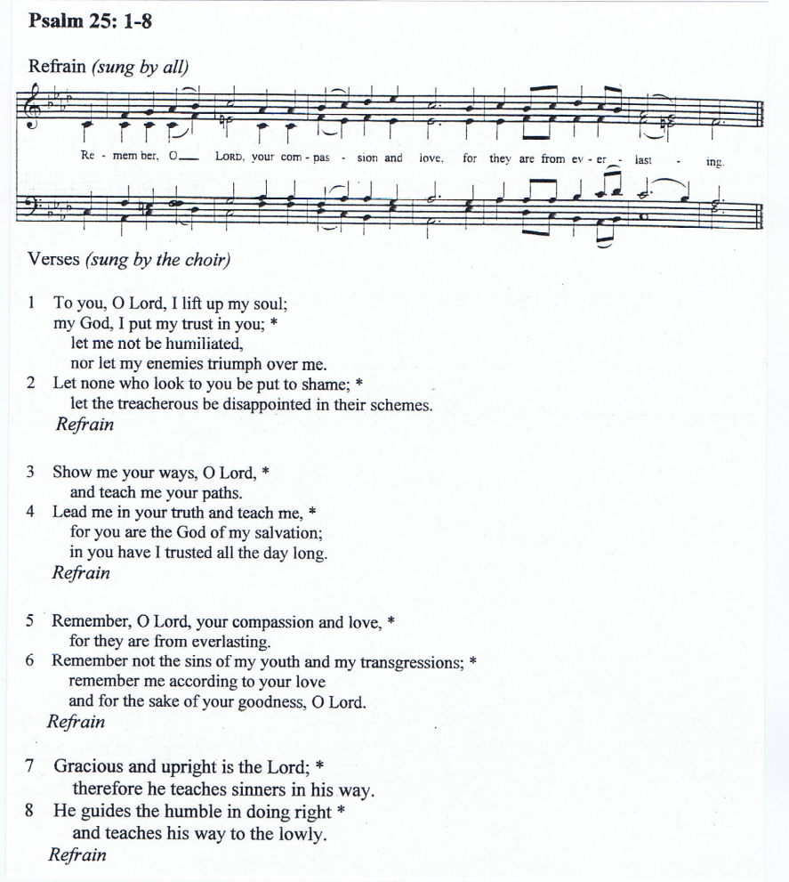
When Jesus entered the temple, the chief priests and the elders of the people came to him as he was teaching, and said, "By what authority are you doing these things, and who gave you this authority?" Jesus said to them, "I will also ask you one question; if you tell me the answer, then I will also tell you by what authority I do these things. Did the baptism of John come from heaven, or was it of human origin?" And they argued with one another, "If we say, `From heaven,' he will say to us, `Why then did you not believe him?' But if we say, `Of human origin,' we are afraid of the crowd; for all regard John as a prophet." So they answered Jesus, "We do not know." And he said to them, "Neither will I tell you by what authority I am doing these things. "What do you think? A man had two sons; he went to the first and said, `Son, go and work in the vineyard today.' He answered, `I will not'; but later he changed his mind and went. The father went to the second and said the same; and he answered, `I go, sir'; but he did not go. Which of the two did the will of his father?" They said, "The first." Jesus said to them, "Truly I tell you, the tax collectors and the prostitutes are going into the kingdom of God ahead of you. For John came to you in the way of righteousness and you did not believe him, but the tax collectors and the prostitutes believed him; and even after you saw it, you did not change your minds and believe him."
Celebrant: The Gospel of the Lord.
People: Praise to you, Lord Christ.

The Sermon Ms. Terry Edwards, Seminarian

Nicene Creed

We believe in one God,
the Father, the Almighty,
maker of heaven and earth,
of all that is, seen and unseen.
We believe in one Lord, Jesus Christ,
the only Son of God,
eternally begotten of the Father,
God from God, Light from Light,
true God from true God,
begotten, not made,
of one Being with the Father.
Through him all things were made.
For us and for our salvation
he came down from heaven:
by the power of the Holy Spirit
he became incarnate from the Virgin Mary,
and was made man.
For our sake he was crucified under Pontius Pilate;
he suffered death and was buried.
On the third day he rose again
in accordance with the Scriptures;
he ascended into heaven
and is seated at the right hand of the Father.
He will come again in glory to judge the living and the dead,
and his kingdom will have no end.
We believe in the Holy Spirit, the Lord, the giver of life,
who proceeds from the Father and the Son.
With the Father and the Son he is worshiped and glorified.
He has spoken through the Prophets.
We believe in one holy catholic and apostolic Church.
We acknowledge one baptism for the forgiveness of sins.
We look for the resurrection of the dead,
and the life of the world to come. Amen.

Prayers for the Season of Pentecost

Leader: Dear people of God, let us pray.
(Pause)

Leader: Great Creator, hear our prayers for your creation. Renew our awe and appreciation for the world you have made. Make us good stewards. Help us cherish the earth, and preserve all life.
(Pause)

Leader: Spirit of God, hear our prayers for humanity. Turn our wars into peace, our cruelty into compassion, greed into generosity, poverty and oppression into prosperity. Grant us the courage and grace to reconcile and restore the human family.
(Pause)

Leader: Divine Majesty, hear our prayers for this nation. Bless and direct all of our elected officials. Guide your public servants as they struggle with the challenges of these times.
Help us work together for the good of all.
(Pause)

Leader: Merciful Savior, hear our prayers for the victims of human violence and natural disasters; for all who suffer in body, mind, or spirit. We commend them to your loving care and ask you to heal their infirmities, return them to your service, and change their sorrow into joy. Give us the knowledge, wisdom, and compassion to mend your wounded people.
(Pause)

Leader: Sovereign Christ, bless forever all who have died and those who are dying now. Give us faith to see in death the gate to eternal life, your arms extended in welcome, and all the saints rejoicing. Confirm our faith and strengthen our hope.
(Pause)

Leader: Spirit of life, hear our prayers for your Church throughout the world, for the Anglican Communion, the Episcopal Church, the Diocese of Virginia, our Bishops Shannon Sherwood Johnston, David Colin Jones, and Edwin F. Gulick; and for St. Timothy’s. Perfect our faith, ignite our passion to accomplish your good will, make us agents of grace. Help us spread faith, hope, love, and joy, throughout your world.
(Pause)

Leader: God of abundance and providence, you made us, named us, love us, and bless us beyond all accounting. We thank you, and we praise you.
(Pause)

Leader: Gracious God, all we are and all we have is a gift from you. We offer ourselves to your service. Help us honor and serve you, now and always. Amen.

The Confession

Celebrant: Let us confess our sins against God and our neighbor.

Most merciful God, we confess that we have sinned against you in thought, word, and deed, by what we have done, and by what we have left undone. We have not loved you with our whole heart; we have not loved our neighbors as ourselves. We are truly sorry and we humbly repent. For the sake of your Son Jesus Christ, have mercy on us and forgive us; that we may delight in your will, and walk in your ways, to the glory of your Name. Amen.

The Absolution

Almighty God, have mercy on you, forgive you all your sins through our Lord Jesus Christ,
strengthen you in all goodness, and by the power of the Holy Spirit keep you in everlasting
life. Amen.

The Peace

Celebrant: The peace of the Lord be always with you.
People: And also with you.
Welcome & Announcements

The Offering

Celebrant: Let us with gladness present the offerings and oblations of our life and labor to the Lord.

Offertory Anthem O, The Blessedness is Great Johann Christian Bechler

