Saint Timothy’s 2016 Budget –
How your money becomes ministry!

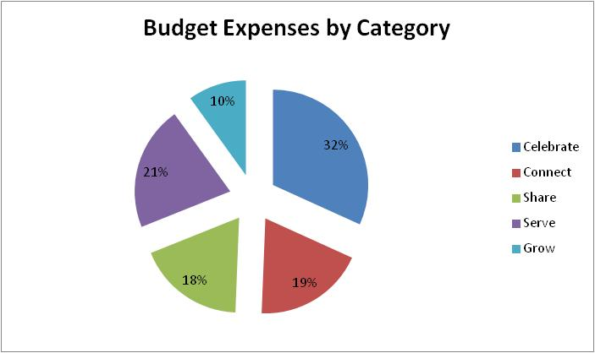

Celebrate: Gathering as a church community to celebrate God’s love ($231,597)
- Hosting Sunday service, morning prayer, evening prayer, and Wednesday Eucharist
- Attracting qualified clergy
- Supporting a music director and three different choirs
- Providing nursery care for infants and toddlers
- Maintaining our sanctuary
- Obtaining Altar Guild supplies for worship
- Clearing the parking lot in inclement weather

Connect: Strengthening our church by caring for each other ($137,341)
- Communicating via the Word, eNews, and bulletins
- Coffee hour
- One-on-one attention through pastoral care
- Matching volunteers to our ministries with needs

Share: Spreading our faith and telling our story to others ($133,309)
- Newcomers’ receptions
- Support to the Diocese
- Sponsoring seminarians
- Outreach at the Herndon Festival
- Spanish language worship for our Latino neighbors
Serve: Doing God’s work wherever we are needed ($154,055)
- Feeding the hungry and clothing the needy here in Herndon
- Providing a safe venue for those recovering from substance abuse—80+ group meetings per month!
- Supporting our pre-school to educate young minds
- Growing men of character through a Boy Scout Troop
- Sponsoring our youth group’s service trip to Dungannon, Virginia
- Sending a team to work on housing with the Lakota in Pine Ridge, South Dakota
- Supporting a team working in Chapoteau, Haiti, and sending children to school

Grow: Deepening the faith of people of all ages ($72,365)
- Conducting Adult Christian education classes on Sundays and weekdays
- Hosting about 20 Bible study group meetings per month
- Providing for youth Christian education classes on Sundays
- Supporting our Godly Play program

