Lay Delegate Guide
Region V Council
Episcopal Diocese of Virginia

Adopted May 13, 2013
This guide was created by the Region V Council to assist churches, clergy, vestries, and candidates in understanding the expectations and responsibilities of a Lay Delegate in the Region and Diocese.

Overview of the Lay Delegate
The job of a Lay Delegate is to provide a link between the congregation and the Diocese by representing the congregation both at regional and diocesan levels, and by reporting back to the congregation on events, actions and decisions that occur.

Selection of Lay Delegates
The Constitution of the Protestant Episcopal Church in the Diocese of Virginia (2012), Article III, entitled “Composition of the Council”, includes specific information regarding selection of lay delegates and alternates. It states that lay delegates and alternate delegates must be an adult confirmed member in good standing and be elected by the vestry of their parish. The term of office is determined by the parish bylaws. Every congregation has at least one delegate; however, churches with a larger number of confirmed communicants in good standing may have more in accordance with Diocesan Constitution Article III. The full text of the Article is attached to this document.
The lay delegates and alternates are certified as such to the Secretary of the Council and then listed on the official voting and mailing lists.
A lay delegate should be someone who can represent the congregation and vote on its behalf on a variety of subjects. A member of the vestry or a retiring warden often makes a good delegate because of intimate knowledge of the workings of that congregation.

Responsibilities of a Lay Delegate
Delegates represent their congregation at any meetings or gatherings of the region.
Delegates represent their congregation at the annual Diocesan Council and any specially convened conventions.
Delegates advise their vestry/mission committee and congregation of issues pending before the region or the Diocese, seek their opinions, and report back to them when actions are taken.
All delegates and alternate delegates should reserve the date of the Annual Council on their calendars, as well as the dates of the Region Council meetings and any other diocesan or region business gatherings (such as Pre-Council Hearings and special meetings of the Diocese).
All delegates should report back to the congregation as a whole as well as the vestry/mission committee after Region Meetings and after annual Diocesan Council. This can take place in a forum, annual meeting, vestry meeting, or through their church’s established communication mechanisms.

Communications to Assist the Lay Delegate
The Diocese of Virginia has a number of ways to help the Lay Delegate stay informed of important issues and events, as well as news, perspectives and discussions of the Diocese:
- Virginia Episcopalian magazine. Published quarterly by the Diocese, the magazine contains diocesan, national and international news and issues.
- Website. www.thediocese.net provides source information and links to external information of value to the Lay Delegate. Of note, all Annual Council registration, preparatory materials and documents are available through the site, as is information about the Regions. During the General Convention of the Protestant Episcopal Church in the United States, the Diocese of Virginia web site hosts blogs and daily updates to keep members informed of the daily discussion and decisions of the Convention.
- eCommunique. An email distributed from the Diocese with news items of general interest, as well as upcoming events and activities hosted at churches around the Diocese. Information about the Annual Council and links to Council materials are also provided through this medium.
- Social Media. The Diocese hosts the following social media sites:
Facebook.com/EpiscopalDioceseofVirginia
Flickr.com/ EpiscopalDioceseofVirginia
Region V Council has two primary methods of communication with members:
- Correspondence is primarily electronic, with email serving as the means by which information is communicated about Region Council meetings, Region events and activities, and parish updates. Information pertaining to Region Council meetings, including preparatory materials for upcoming meetings, is generally distributed by the Region Secretary.
- A social media site was established in late 2012 on Facebook to assist collaboration and communication among the members of Region V Council and to communicate Region V events and activities.
Lay Delegate Role in Diocesan Council

Diocesan Governance
The Episcopal Diocese of Virginia has various governing bodies and documents. The lay delegate should be familiar with these institutions to most effectively execute their responsibilities at the diocesan and regional levels. The source documents and additional information about each of these governance institutions may be found on the Diocesan website.
The Constitution & Canons are the documents by which we govern ourselves.
The Annual Council is the main governing body of the Diocese of Virginia.
The Executive Board meets to conduct Council business in between sessions of Council. The Board consists of one lay or clergy representative elected from each region.
The Standing Committee is the council of advice to the Bishop.
General Convention is the triennial governing meeting of the Protestant Episcopal Church in the United States.
The Deans and Presidents are clergy and lay representatives of each Region.

Prepare for Council
Preparing Delegates. The outgoing delegates should assist the rector or vicar in training the new delegates. This includes ensuring that the paperwork is filed with the Diocese by the rector/vicar for the new delegates so that they may receive official communications; passing on pertinent materials (Diocesan and Region level); explaining structure, unfamiliar terms and current issues; and introducing the new delegates at larger gatherings.
Delegation Meeting. The delegation from the congregation, including all alternate delegates, should meet together and/or with the vestry for discussion of issues at hand. Retiring lay delegates should pass on information to the new lay delegates and alternates. All information should be shared with alternate delegates, as they may be called upon unexpectedly to act on behalf of the lay delegates.
Pre-Council Hearings. Approximately two weeks prior to Annual Council, the Diocese hosts a meeting to inform delegates of any specific issues relative to Council and to enable each Committee of the Diocese to conduct hearings. The Committee Hearings enable delegates to provide feedback to or ask clarifications of the Diocesan Committees relative to the proposed amendments to the Constitution and Canons, the budget, the proposed resolutions, or other matters that will be presented for vote at Council.
Review of Materials. Every delegate should review the entire contents of the Council materials available on the Diocesan website and come prepared to vote at Council. It is also helpful to review the Rules of Order and tips on parliamentary procedure.
Orientation of New Delegates at Convention. There may be an orientation to orient first-time Lay Delegates that includes things like what to expect when you vote, some education about parliamentary procedure, and other things pertinent to the specific Council.

What to Expect at Diocesan Council
This is the annual business meeting of the Diocese and is presently held late in January, alternating between locations in Northern Virginia and the Richmond area. Council conducts elections; votes on the budget, resolutions and any other actions presented; hears reports; and conducts any other business of the Diocese. It includes both the Clerical Order and the Lay Order, as well as members of Council ex officio, and guests. Approximately 1,200 people attend the annual Council.

The agenda for Diocesan Council is published several weeks prior and is available on the Diocesan website and through other communications. The business sessions, presided over by the Bishop, are the primary objective of Council and include the Bishop’s address, appointments, elections requiring vote of the Council, reports of various committees and commissions, budget approval, and any other business of the Diocese. In addition, Council activities may include workshops, an orientation session, nominations hearings, exhibits of various ministries and organizations, social events and worship. The Lay Delegate should be familiar with the agenda and plan to participate in all business sessions of Council.
Region Structure
The Diocese of Virginia has 15 regions, determined by geography. Each region has a Regional Council, composed of members elected by the churches in each region. Each region has an elected President, who is a lay person, and an appointed Dean, who is a clergy person. The geographical proximity of the churches within a region enables greater collaboration and effectiveness, especially in areas of shared ministry or shared responsibility.

Deans and Presidents
The Deans of the 15 regions of the Diocese of Virginia are appointed by the Bishop and are the Bishop’s representatives in each region. Together with the Presidents of the regions, they lead their regional council in ensuring the ministrations of the church area available to all persons in each region.
The Presidents of the 15 regions of the Diocese of Virginia are elected by each Regional Council. Each Regional Council is composed of members elected by the churches within each region. The Presidents work with the Deans of each region to convene the Regional Council and ensure the ministrations of the church are available to all persons within the region. Regional Councils also elect representatives to the Executive Board.
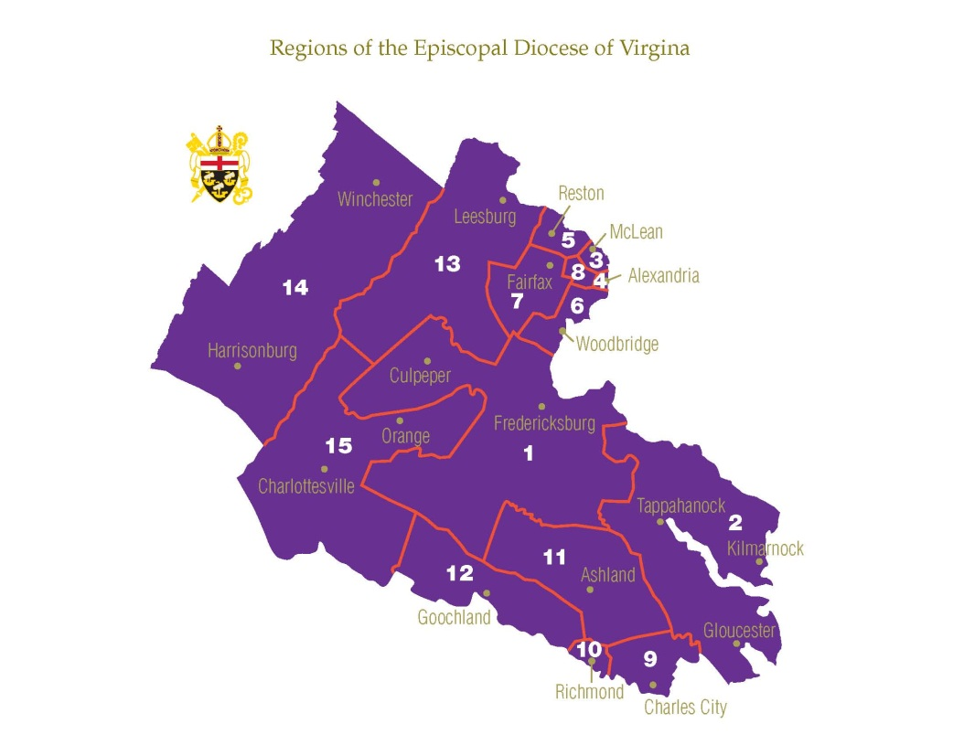
Region I: Fredericksburg, Culpeper and surrounding areas
Region II: The Northern Neck and Middle Peninsula
Region III: Arlington
Region IV: Alexandria
Region V: Northern Fairfax
Region VI: Alexandria south to Woodbridge
Region VII: Western Fairfax
Region VIII: Falls Church and Annandale
Region IX: Richmond east to New Kent and Charles City counties
Region X: Richmond city
Region XI: Northern Richmond north to Ashland and Hanover
Region XII: Richmond west through Goochland County
Region XIII: Loudoun and Fauquier counties
Region XIV: Shenandoah Valley
Region XV: Charlottesville north through Green and parts of Orange counties

Region V: Northern Fairfax

Region V, geographically representing Northern Fairfax County, includes the following churches:

Church of the Epiphany, Herndon

Church of the Holy Comforter, Vienna

Church of the Holy Cross, Dunn Loring

St. Anne’s, Reston

St. Dunstan’s and St. Francis Korean, McLean

St. Francis, Great Falls

St. John’s, McLean

St. Thomas, McLean

St. Timothy’s, Herndon
The objective of Region V Council, as led by the appointed Dean and elected President, is to ensure the ministrations of the church area are available to all persons in the region. Our mission is to engage in common ministry where the pooling of resources may create a more effective and efficient program. Region V has shared ministry for Young Adults, the Dungannon Mission Trip for youth, and workshops offered by the Commission for the Prevention of Sexual Misconduct. The Region Council seeks greater opportunity for shared mission across our churches for greater impact in the Northern Fairfax geographic area.
Region V Council is responsible for electing a representative to the Executive Board of the Episcopal Diocese of Virginia. In addition, the Region Council may endorse nominees for Diocesan positions for election at annual Diocesan Council and may sponsor Resolutions for vote at annual Diocesan Council. The Region V Council may also elect a Youth Delegate (not over 21 years of age) to annual Diocesan Council.
Elections are held annually for Region V officers – President, Vice President, Secretary and Treasurer, in accordance with the Region V By-Laws.

Attachment 1: The Constitution of the Protestant Episcopal Church in the Diocese of Virginia
(selected excerpts)
Article III. Composition of the Council.
Section 1
(a) The Council shall be composed of the Clerical order and the Lay order.
(b) The Clerical order shall consist of the Bishop or Bishops and all other ministers canonically resident in the Diocese of Virginia. No member of the Clerical order under ecclesiastical censure shall be entitled to a seat in the Council.
(c) The Lay order shall consist of two classes, namely: (1) the Lay Delegates from the church and (2) the Lay members ex officio.
(d) There shall be only one Lay Delegate from each church, to be chosen by its Vestry. But from every church having more than three hundred confirmed communicants in good standing reported to the Diocesan authorities in the last annual report, there shall be an additional Lay Delegate for each three hundred confirmed communicants in good standing, or major fraction thereof, above the first three hundred.
(e) The Lay members of the Standing Committee, the Lay members of the Executive Board, the Chancellor, the Presidents of the Regions, the President of the Episcopal Church Women of the Diocese, one Youth Delegate (not over 21 years of age) elected by each Regional Council on or before May 1, and two lay persons, not over 25 years of age at the time of election and participants in an Episcopal higher education ministry in the Diocese, to be elected by the Standing Committee on or before May 1 as Collegiate Delegates shall be members of Council ex officio.
(f) Each elected Delegate and ex officio member shall have one vote.
Section 2. The Lay Delegates shall serve for the regular meeting for which they are chosen, and, unless other delegates be chosen, for any special meeting held prior to the next regular meeting of the Council.
Section 3. All Lay members of the Council shall be adult confirmed communicants in good standing, as defined in the General Convention Canon I.17 of the Episcopal Church, in the Diocese of Virginia.

Canon 2. Lay Representation in Council.
Section 1. The Churches of this Diocese entitled to Lay representation in the Council are those which were recorded by the Secretary of the Council as Parish Churches or Separate Congregations on the effective date of this Canon, together with Churches thereafter constituted in accordance with Canon and received into union by act of the Council.
Section 2. The Missions of this Diocese entitled to Lay representation in the Council are those which were recorded by the Secretary of the Council as such on the effective date of this Canon, together with those Missions thereafter constituted in accordance with Canon and reported as such to the Secretary of the Council.
Section 3. A list of the Churches and Missions entitled to representation in the Council shall be appended to the Journal of each regular Council.
Section 4. The Vestry of a Church, or the Vestry Committee of a Mission, shall elect not later than April 1 the Lay Delegates from that Church to the Council, and shall also elect one Lay Alternate for each Lay Delegate elected. For Churches entitled to multiple Lay Delegates, the Vestry may designate the order in which the Lay Alternates are to serve in the event Lay Delegates are absent. In the event a Lay Delegate is absent and no Lay Alternate is available, the Vestry, or if the Vestry is unavailable, the Rector or Vicar, in consultation with the Wardens, shall appoint a person qualified to serve as a Lay Delegate and so advise the Credentials Committee.
Section 5. The election of adult confirmed communicants in good standing as Lay Delegates and Lay Alternates to Council shall be certified by the Rector, Vicar, Register, Priest-in-Charge, or one of the Wardens of the proper Church, in duplicate, which certificate shall be in a form to be supplied by the Secretary of the Diocese. One copy of this certificate shall be sent to the Secretary of the Diocese no later than April 15, and a copy shall be given to each Delegate and each Alternate named therein.
Section 6. Lay Delegates of Churches, or in their absence, their Alternates, shall be entitled to one vote each on all questions coming before the Council. Alternates shall not be entitled to voice and vote in the meetings of the Council except when serving in the absence of a Lay Delegate.
Section 7. The Secretary of the Diocese shall make a roll of the Lay Delegates and Alternates certified to him as duly elected with their respective Churches. The President of the Council shall appoint a Committee on Credentials, to be composed of one Clergyman and two Lay Delegates, to which shall be referred the credentials of all Lay Delegates. The Committee shall make its report to the Council promptly. Until this report be received, the roll as made by the Secretary shall, unless objection be made, be accepted as the authentic roll of Lay Delegates and Alternates. Should doubt arise as to the right of any Lay Delegate or Alternate to his seat, the Committee on Credentials shall hear the evidence presented and report its judgment. Upon this report the Council shall determine the matter unless by a vote of two-thirds of the members present the Council decides to hear the whole case de novo.

